TASK OF THE DAY
INPUT:
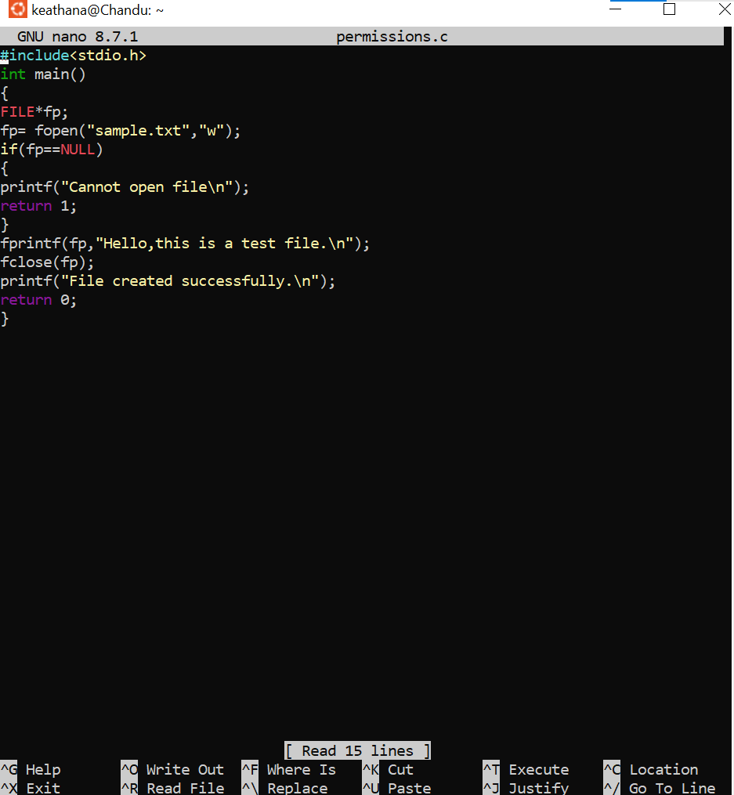

1) Give Read and Write only to the owner
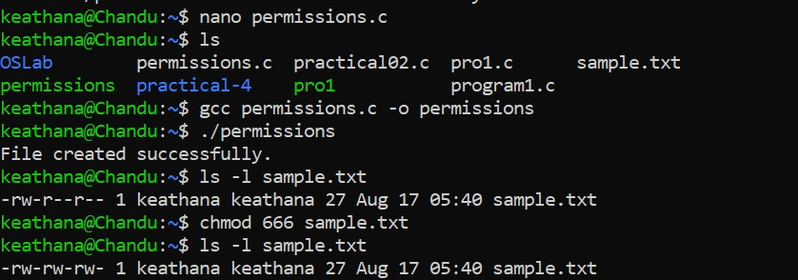
2) Give Read and Write to the owner and group
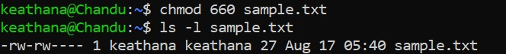
3) Only owner can read and write
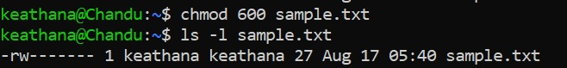
4) Owner read/write, everyone else read-only
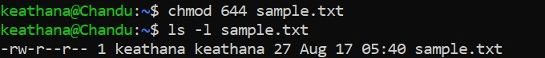
5) Owner can do everything, others can only read and execute
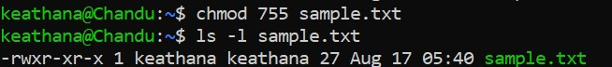

6) Owner and group can read/write
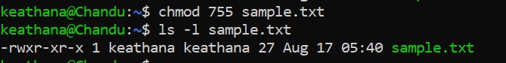
7) Only owner can execute
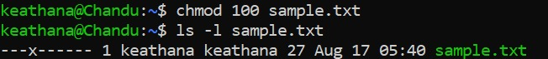

Fill in the permission numbers for the following:
8) Owner: read + write; Group: nothing; Others: nothing →___600_________
9) Owner: read + write; Group: read; Others: read → ___644______
10) Owner: read + write + execute; Group: read + execute; Others: read + execute → _755________
11) Owner: read + write; Group: read + write; Others: nothing → ____660________
12) Everyone: read only → ___444_________

WHOLE OUTPUT
